A LITTLE POT LUCK PARTY PAI TI KONG WITH THE GHOSTS (DOUBLE HAPPINESS)
Jayanto Tan

Maitland Regional Gallery 3 December – 12 March 2022

All artworks ceramic

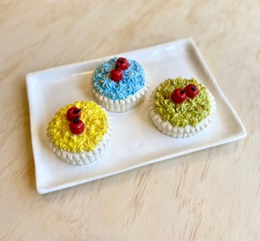
Mon Cherie Amour Tarts, 25x18x06cm $1500.00

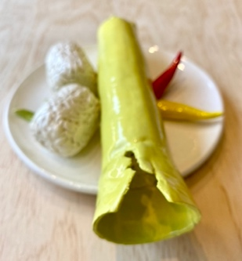
Lemang Rice Bamboo Snack, 24x19x06cm $1500.00

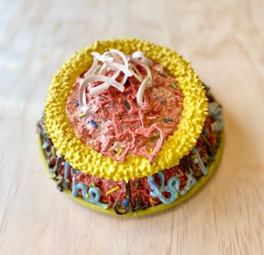
Shuāngxǐ (double happiness) Cake, 19x19x10cm $1500.00

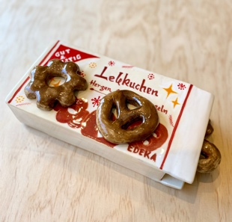
Gut & Gunstig Lebkuchen, 30x12x09cm $1500.00

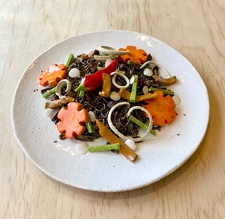
Jajangmyeon Korean Black Noodles, 19x19x05cm $1500.00

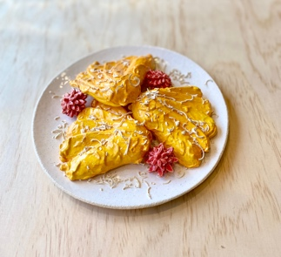
Pisang Goreng, 19x19x04cm $1500.00

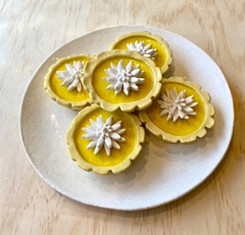
Egg Tarts, 20x20x05cm $.1500.00

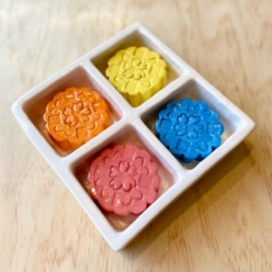
Mini Moon Cakes, 17x17x04cm, $1500.00

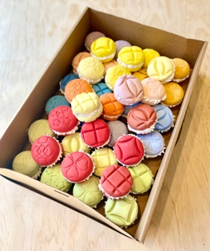
41 Colourful French Macaroons in Found Box, 35x25x10cm $2500.00

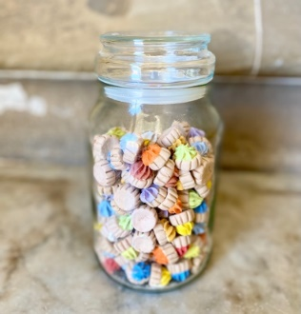
Colourful Iced Germs Biscuits in Found Jar, 12x12x22cm $1500.00

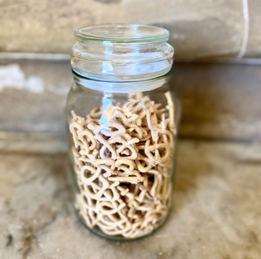
Mini Pretzels in Found Jar, 12x12x22cm $1500.00

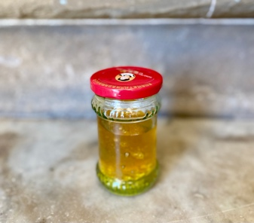
Chrysanthemum Tea in Found Jar, 08x08x11cm $500.00

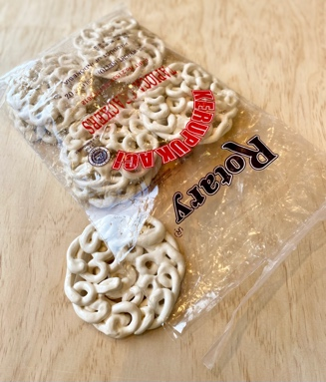
69 Kerupuk (Tapioca Crackers) in Packaging, 25x30x12cm $950.00

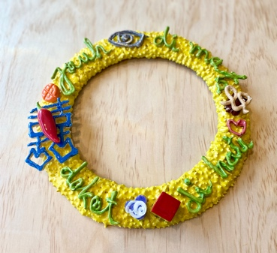
Lemonade Crown of Thorns, 25x25x04cm $850.00

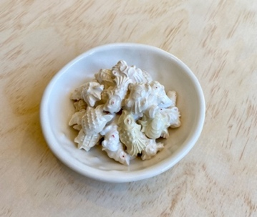
Mini Kue Bangkit (Sago Rise Cookies), 5x15x06cm $500.00

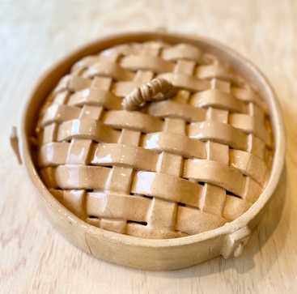
Bamboo Steamer Cover, 25x25x08cm $1500.00

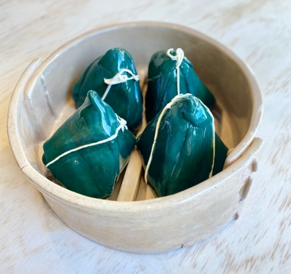
Bak Cang Sticky Rice Dumplings, 21x21x09cm $2500.00

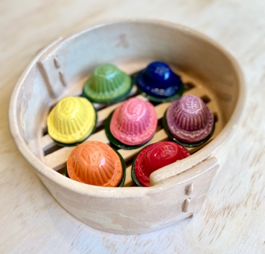
Colourful Ang Ku Kue Tortoise Snacks, 21x21x09cm $2500.00

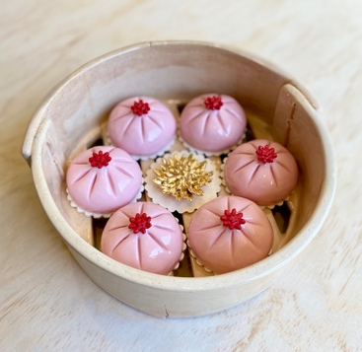
Pink Bao Steamed Sweet Buns with Gold Flower, 21x21x09cm $2500.00
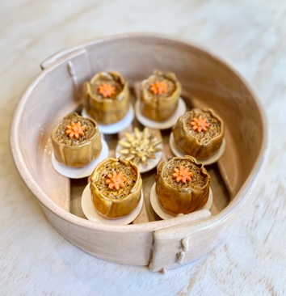
Siomay Steamed Fish Dumplings with Gold Flower, 21x21x09cm $2500.00

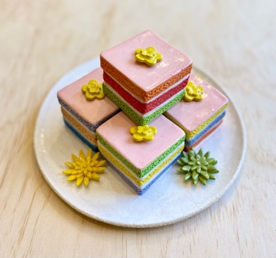
Colourful Sponge Tea Cakes, 23x23x10cm $1500.00

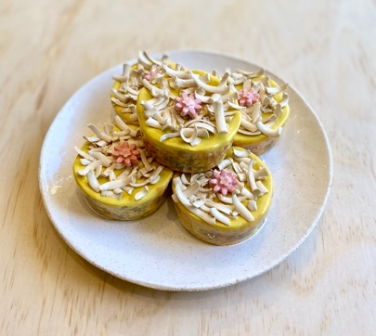
Kue Lumpur (Mud Cakes) with Pink Flower, 19x19x07cm $1500.00

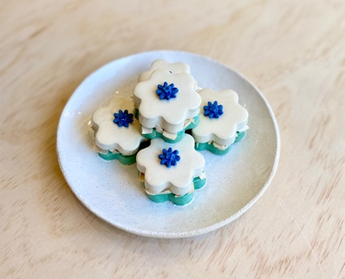
Kue Bangkit (Sago Rise Cookies) with Blue Flower, 19x19x07cm $1500.00

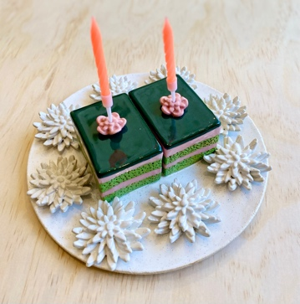
Pandan Sponge Cake with Orange Candles, 19x19x06cm $1500.00

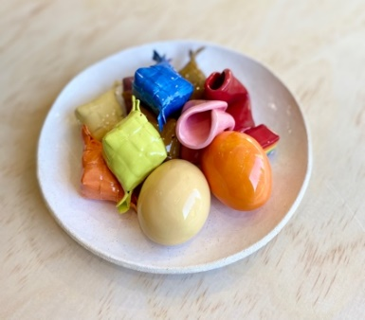
Assorted Love Snacks with Fortune Cookies, 19x19x06cm $1500.00

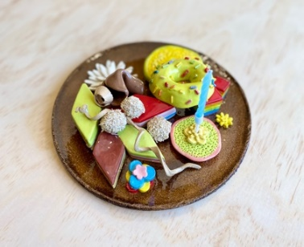
Assorted Love Snacks with Blue Candle, 19x19x06cm $1500.00

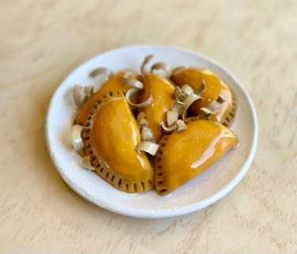
Curry Puffs with Crackers, 17x17x05cm $1000.00

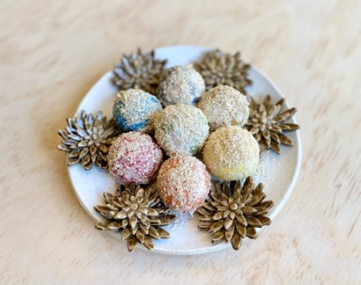
Colourful Onde Onde (Rice Balls with Brown Sugar), 17x17x05cm $1000.00

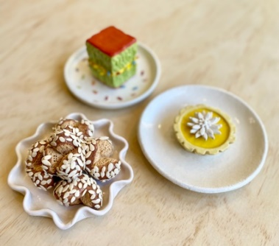
Egg Tart, Sesame Balls and Sweet Martabak, dimensions variable $1050.00

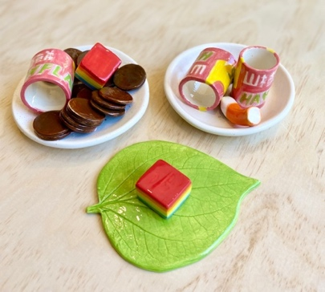
Haw Flakes, Rainbow Liquorice on Daun Sirih, dimensions variable $900.00

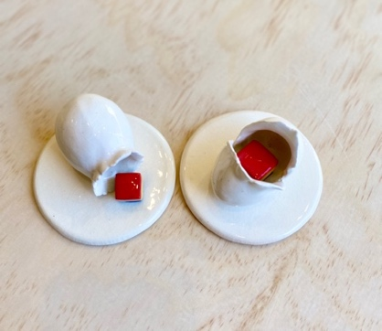
Comin’ In and Out of Your Life, dimensions variable $500.00

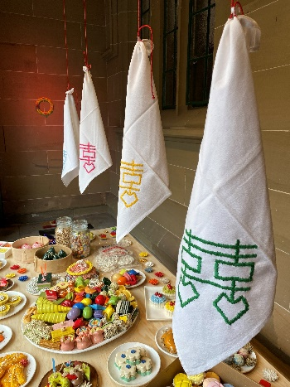
Si (四Four) Embroidery Shuāngxǐ on Found Napkins, 45x45cm $600.00

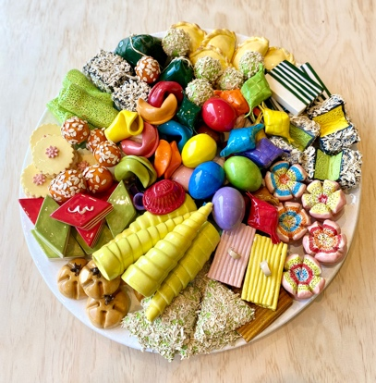
Pai Ti Kong Feast, 50x50x12cm $9999.00

